INSTRUCTIONS FOR CANDIDATES - MORA & IH PROJECT

HOW TO APPLY:

- Step-1 Visit NTS website and Apply for relevant Project: Interested candidates must visit NTS official web site: www.nts.org.pk to apply/register online for the test. Go to Open Application and Select “Ministry of Religious Affairs and Interfaith Harmony (M/o RA & IH) Screening Test for Hajj Medical Mission for Hajj Operation 2024”.
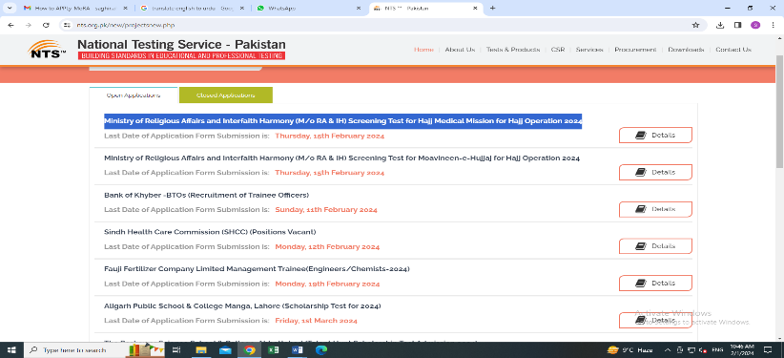

- Step-2 Sign Up: Apply for the relevant position/post and sign up if not registered before on NTS website. Relevant Details of the project can be viewed/downloaded if required so. Fill in relevant details for sign up. One-time password (OTP) will be sent on your email address. Insert the OTP on candidate portal and press Submit.
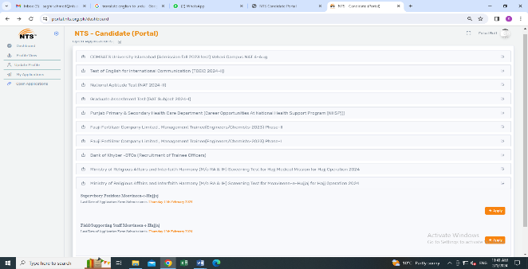
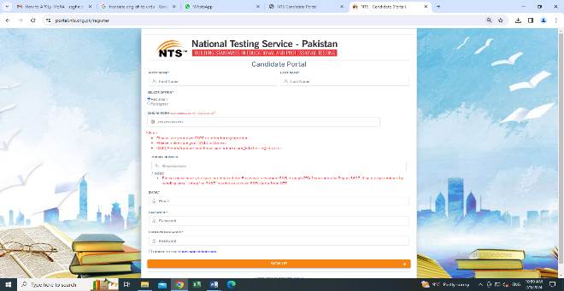

- Step-3 Sign In and Complete Profile: For Sign In/Login enter Login ID (CNIC) and password. Press Update Profile Tab on left side of the screen and fill in the required information if new Profile is being created and submit. Applicants already having profile will Sign/Login on NTS website and may update their profile information if desired so and submit.
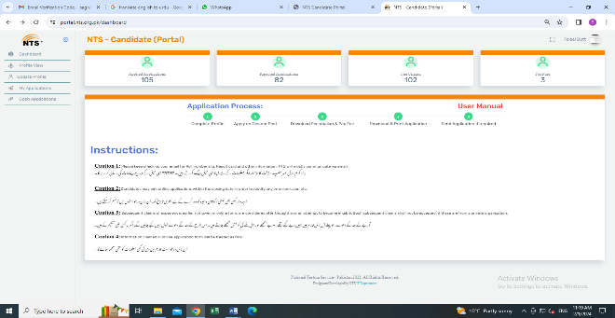

- Step-4 Apply for the relevant Project/Position: click Open Application Tab, select relevant project and apply for the relevant position. Answer the relevant questions and Apply Tab.

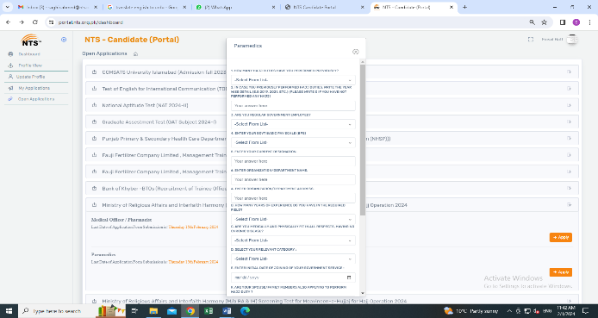
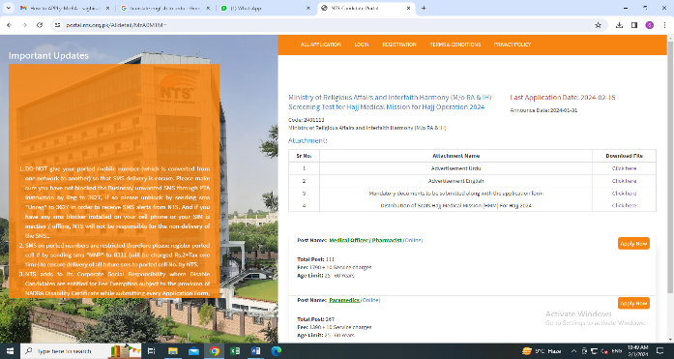

- Step 5 Download Fee Challan: Print/ download the fee challan if required so. NTS Test Fee can only be paid via 1Link 1Bill Participating Banks/ATM/Internet, Banking/Mobile Banking/EasyPaisa/JazzCash/TCS Express Counters by downloading fee challan/deposit slip from NTS website. After payment of test fee, application form can be viewed/downloaded. Status of application and test fee payment status can be viewed by clicking Tab “My Application”.
- Step 6 Dispatch of Online Application Form and required documents to NTS: The candidates shall submit Hard copy of duly online filled application form along with photocopies of required documents as applicable i.e (Nomination Performa, Medical Fitness Certificate, Service & NOC, Hajj Acceptance Form, Surety Bond, COVID Certificate, AGPR recent Pay slip etc) to NTS Headquarters (MoRA Project)), plot #96, street # 04, Sector H-8/1, Islamabad till last date of application submission. Specimen forms can be downloaded from NTS and MoRA & IH website.
- Shortlisted candidates will be required to submit above mentioned document s in original as and when asked by MoRA & IH through its own mechanism.
- Application Forms filled improperly, incomplete, without required documents and submitted by hand will not be entertained.
- Only online filled Application Forms will be entertained. Hand written Application Forms will not be entertained.
- User Manual and short video for fee payment through various means is also available on NTS website.
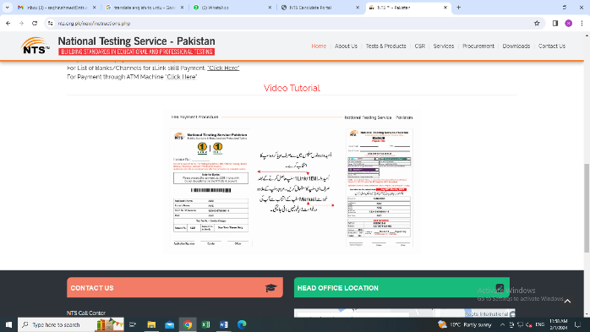
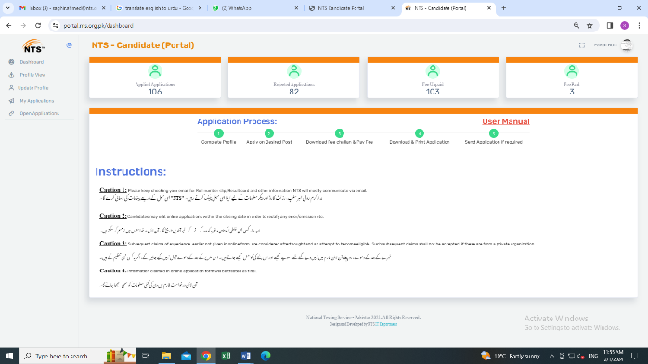

- For further test related information/query/updates, Test date and syllabus, please keep visiting NTS website www.nts.org.pk or call helpline at 051-8444441.

SPECIAL INSTRUCTIONS FOR CANDIDATES:

- HMM applicants are advised to apply only against their relevant Province/Region seat, if available. Detail can be viewed in HMM distribution of seats (attached).
- HMM Candidates are advised to apply against relevant Province/Region seat as per their own domicile.
- Candidates applying domicile in one Province/Region applying for another Province/Region seat will be considered ineligible.
- Doctors/Pharmacists and Paramedics can apply for Moavineen-e-Hujjaj with separate fee.
- Disable and Non-Muslims candidates are ineligible to apply.

